**PRACTICAL 17:**

**DISTANCE IN MARATHON**

**CODE:**

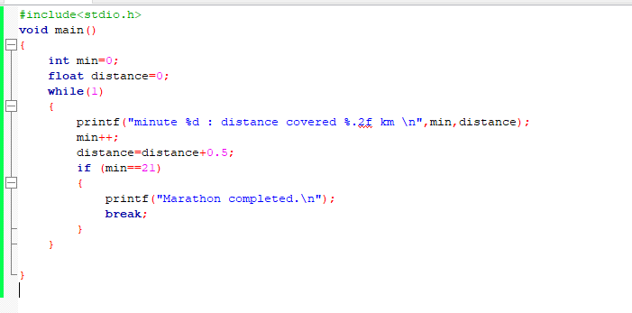

**OUTPUT:**